Can we live under water?
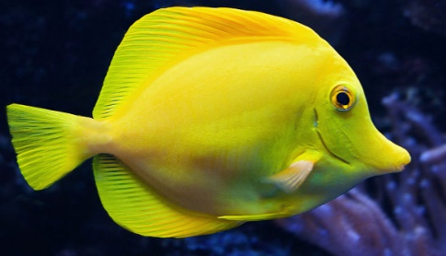
Have a go at answering these questions then label the fish.

- What do we breathe into our lungs from the air around us?

- Do fish need this too?

- How do fish get this into their bodies? What adaptation do they have which means they can live under water?

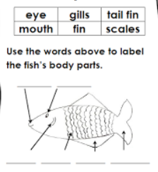
- Can fish live out of the water? Why not?

