Shark questions
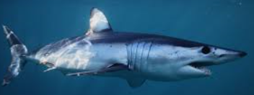

- Are sharks a mammal or a fish?

- Name 2 kinds of sharks you heard about in the video:

- Can sharks breathe air?

- How does a shark get oxygen into it’s body? (this question is a tricky one!)

- What did you learn about the teeth of a shark?

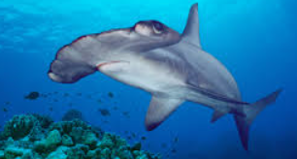

- Any other facts you learnt:

