Old and new boats
Have a look at these two pictures. One is of an old boat, one is a new modern boat. Decide which one is which and describe them. What is the same? What is different?
This is | This is
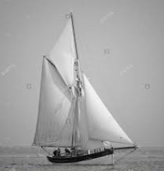 | 