When I look through my telescope, this is what I can see………
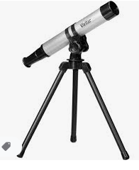

Where were you when you looked through your telescope?

