Virtual Sports Week

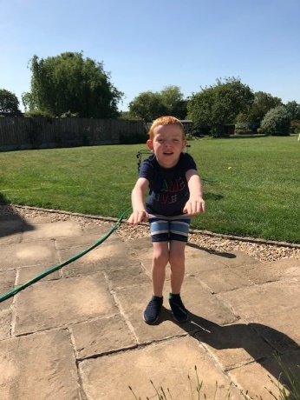
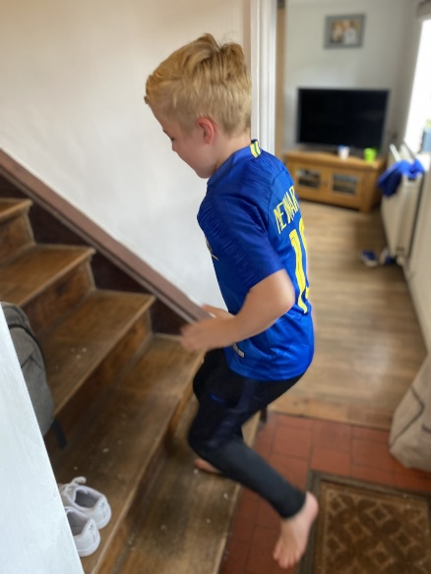
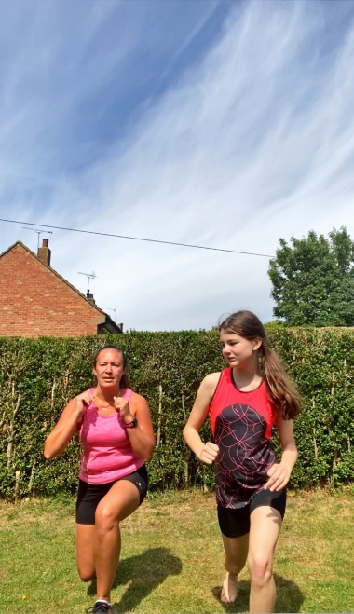
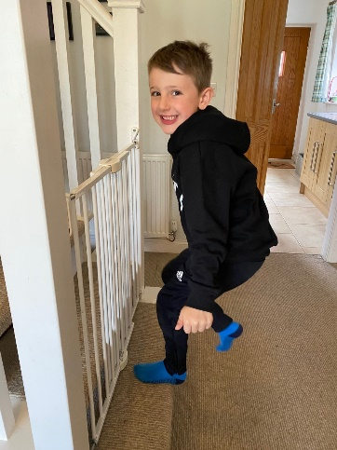
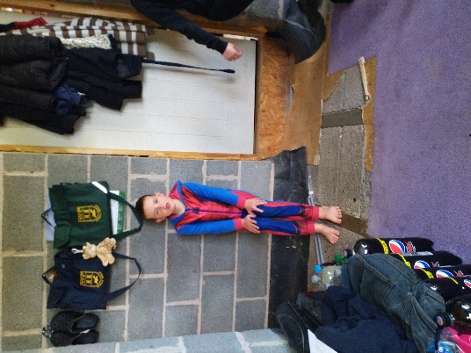
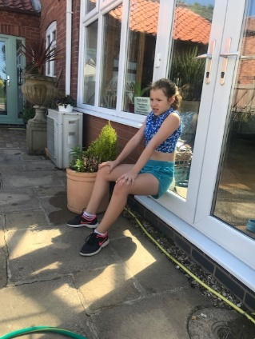
A huge well done to everyone who took part in our ‘Virtual Sport’s Week!’ We have had lots of entries and some super points scoring for your house teams. Below are a selection of the photographs sent in. All of the photographs sent in are available to view on the website.

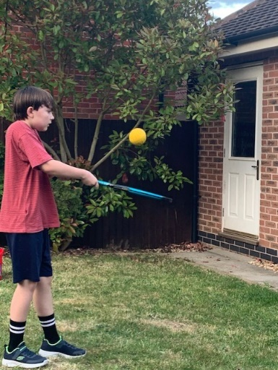

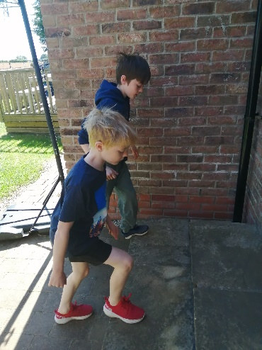

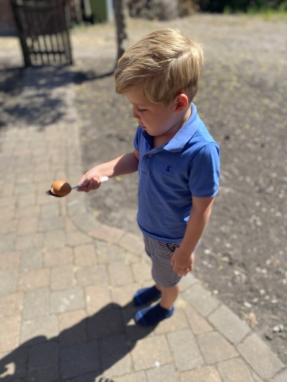
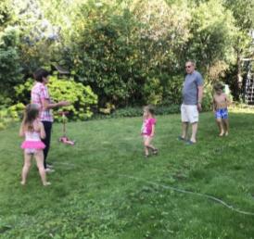
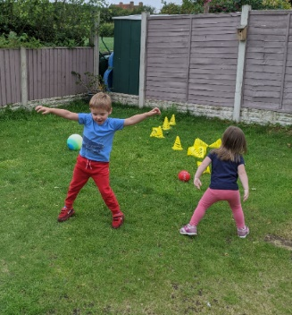

Great action shots children! I particularly like the ones where you got your parents and even grandparents involved! For everyone who took part, Mrs.Bartlett has sent a certificate to you and I will put 5 house tokens into your house pot…well done!
After tallying up the points from each child we can reveal the winners are….

1st Place – 40 house points with a total of 1553 points
ASH
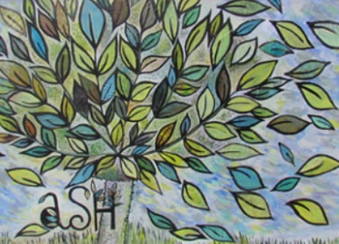

2nd place – 30 house points with a total of 1345 points
OAK
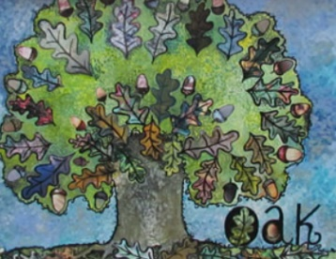

3rd place – 20 house points with a total of 1069 points
BEECH

4th place – 10 house points with a total of 995 points
SILVER BIRCH
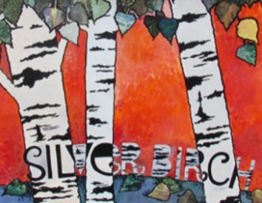

Well done everyone!

