Home Learning – Summer Term
Under the Sea – Non-fiction – Sea Creatures
As a guide, we would expect children to do at least three of the literacy activities per week and at least one of the topic activities. We would also expect children to read, practice the sounds of the week (phonics) and complete doodle maths on a daily basis (See the separate suggested timetable for more support if needed)
Weekly book focus | Literacy activities (sheets attached) | Weekly topic activity ideas
https://youtu.be/XqP0xqbnAMU  Seahorse video  https://youtu.be/9vQnKO_2kKk  Giant Pacific Octopus video  https://youtu.be/TFzpC_e44Tg  An amazing video showing an octopus walking over land! | Watch the sea horse video and then write some facts about them. How do they travel? Who gives birth to the babies? Where can they be found in the world? Draw a picture of a seahorse too.  Watch the octopus video. Octopus live and breather underwater. What do they eat? How do they hide themselves? Can you use the word camouflage in your writing? Remember, camouflage means to hide themselves. How do some octopus manage to travel over land? (using suction cups!) Write some facts about Octopus and draw a picture!  Under the sea rhyming words – can you think of three words that rhyme with each word? Now choose three of the words and write in a sentence. See if you can use an exciting adjective to describe. E.g. The colourful fish swim in the dark blue sea.  Look at the Under the sea powerpoint – what animals live underwater? Can you guess the animal in each one before revealing? Can you write a list of the different species you would find and draw a picture of each one. | Sea creature habitats – watch the four videos showing the different habitats in the ocean.  - Fish in the coral reef  - Flat fish in the sand  - Bottom of the ocean  - Shallow water fish  Discuss the differences in the habitats? E.g. The bottom of the ocean is dark whereas the shallow water is light. Can you think of any other habitats in the ocean? Coral reef, seaweed, under rocks. Explore which animals live there and how they have adapted to survive.  How do fish breathe underwater? Try the science experiment to explore a little more about how the gills on a fish work.  Sea food chain – look at the powerpoint/pdf explaining what a food chain is. This is quite a detailed powerpoint but worth a look. Have a go at the food chain activity sheet.  Additional activities…  Try some under the sea art work; here are some ideas but feel free to have a go at your own painting/collage/sketching.  https://www.pinterest.co.uk/juliereid/ocean-animal-crafts/  Try the under the sea addition activity to 20 or the crack the code sheet (the crack the code is a bit trickier)
If you do not have the weekly book available at home, we have provided a you tube link for your child to listen to the story.
Daily phonics/reading – see separate overview for Mrs.Bacon/Mrs.Sharphouse and Mrs.Witham’s phonics group.
In terms of reading, we have set each child an account up on Epic reading. This will allow them to access reading books online. Head to www.getepic.com/students and follow the instructions below.
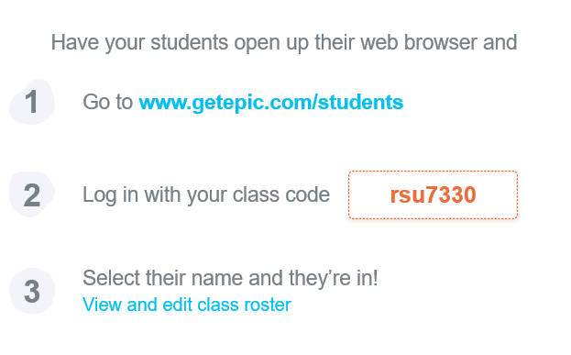

Daily Maths – please continue to use Doodle Maths where we will set challenges for the children. The ‘White Rose Home Learning Programme’ is also fantastic if you wish to have a go. Follow this link https://whiterosemaths.com/homelearning/ and click on the Early Years group on the right hand side of the screen.
.

