Home Learning – Summer Term
Under the Sea – Pirates
As a guide, we would expect children to do at least three of the literacy activities per week and at least one of the topic activities. We would also expect children to read, practice the sounds of the week (phonics) and complete doodle maths on a daily basis (See the separate suggested timetable for more support if needed)
Weekly book focus | Literacy activities (sheets attached) | Weekly topic activity ideas
‘Pirates love underpants’ by Claire Freedman and Ben Cort.  https://youtu.be/Vd8_Y1bEzA8 | - What do pirates actually do? Look at the information provided and write some facts about pirates and draw a picture.  - What would items would a pirate need to take on his journey? Look at the sheet provided to help. See if you can use this to help you make your own list. Try and sound out the words without copying them directly. Extension – Choose 3 objects and write them in a sentence.  - Look at the information on famous pirates. Choose your favourite one and write some sentences about him/her. You can draw a picture too.  - Can you label the pirate ship? Use the information sheet to help you find out about Pirate ships. Extension – You could always choose two or three of them and find out more information about them. Write them the information in sentences. | Can you make a pirate treasure map? Remember ‘x’ marks the spot! See if you can draw a route around your map or direct a duplo/lego person around it using direction words such as left, right, up, down. You could even look at the marks on a compass. See if you can remember North, South, East, West. You can use the sheets provided or make up your own!  We would like you to have a go at a pirate science experiment this week. We have included a number of different ones to try. Send us a photo of you doing it!  Can you learn and perform this song? It would be great to see some videos from you.  https://youtu.be/YOA3he2Gv4M  Additional activities…  Make a split pin pirate (or use glue if you have no split pins!)  Can you make a paper plate parrot?https://www.craftsonsea.co.uk/paper-plate-parrots/ Or, choose one of your own pirate craft ideas.  Can you make a pirate hat? Follow the instructions provided to help. Send us a photo of you wearing it!
If you do not have the weekly book available at home, we have provided a you tube link for your child to listen to the story.
Daily phonics/reading – see separate overview for Mrs.Bacon/Mrs.Sharphouse and Mrs.Witham’s phonics group (If you are unsure which group your child is in, please don’t hesitate to e-mail us to find out.)
In terms of reading, we have set each child an account up on Epic reading. This will allow them to access reading books online. Head to www.getepic.com/students and follow the instructions below.
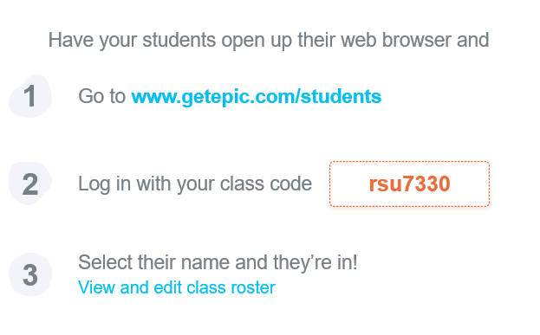

Daily Maths – please continue to use Doodle Maths where we will set challenges for the children. The ‘White Rose Home Learning Programme’ is also fantastic if you wish to have a go. Follow this link https://whiterosemaths.com/homelearning/ and click on the Early Years group on the right hand side of the screen. Each day, there is a new lesson which is accompanied by a teaching power point.

