Home Learning – Summer Term 2 Week 3
Under the Sea – fiction and non-fiction
Weekly book focus | Literacy activities (sheets attached) | Weekly topic activity ideas
‘Dougal’s deep sea diary’ by Simon Bartram.  https://www.youtube.com/watch?v=ULjWgbz1nDw  ‘Barry, the fish with fingers’ by Sue Hendra.  https://www.youtube.com/watch?v=5yQPruodTjM  Coral Reef:  https://www.youtube.com/watch?v=J2BKd5e15Jc  (a little too detailed but fun to watch and learn about coral reefs)  Can we live underwater?  https://www.youtube.com/watch?v=zj5v3n6Nlm8 | - What exciting adventures Dougal got up to! Now imagine you were to go on a deep sea adventure! What would you do, what would you see, what exciting/scary/problem situation may occur and how will you solve it? Think about the beginning of your story, what happens in the middle, and how it will end.  If you can use some adjectives (describing words) in your writing, that would be fantastic – for example, the sparkling sea, the tiny orange fish.  - watch the You Tube video all about coral reefs. You don’t have to remember it all but doesn’t it look amazing? What are some of the creatures you saw? Make a list in your books.  - Would you like to live underwater and swim around coral reefs? Why can’t we live underwater like fish can? Watch the YouTube clip – she speaks very fast but it’s very interesting and tells you how fish have adapted to live in water. | - Use the colouring sheet to colour, cut out and make your own under sea scene – is that Dougal in his diving suit?  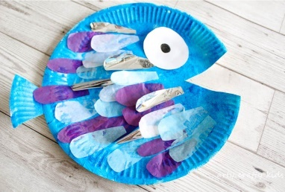  - Can you make a paper-plate fish? If you don’t have a paper plate, just use a circle of card.  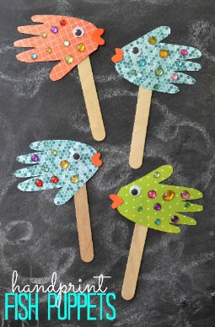  If you have a lolly stick you can use, draw around your hand, cut it out, decorate it and give it an eye and you have made a fish puppet!
Daily phonics – see separate overview for Mrs.Bacon/Mrs.Sharphouse and Mrs.Withams phonics group.
Daily Maths – please continue to use Doodle Maths where we will set challenges for the children.

