Home Learning – Summer Term 2 Week 5
Under the Sea – transport over and under the sea
As a guide, we would expect children to do at least three of the literacy activities per week and at least one of the topic activities. We would also expect children to read, practice the sounds of the week (phonics) and complete doodle maths on a daily basis (See the separate suggested timetable for more support if needed)
Weekly focus | Literacy activities (sheets attached) | Weekly topic activity ideas
Sea transport powerpoint:  T-T-4959-Sea-Boats-Transport-Photo-Powerpoint_ver_1.ppt  Loading and unloading of a container ship:  https://www.youtube.com/watch?v=isIcqkYUHws  Very important ships have special naming ceremonies – this one, Britannia, was named by the Queen five years ago and a bottle of champagne is thrown and smashed against the side!!  https://www.youtube.com/watch?v=on-uj75fGPI | Watch the powerpoint and discuss each of the sea transports – what are the similarities and differences with each and how would they be used? Have you travelled on any of these?  Which one of these can also go under the water?  In your books, draw this type of sea transport and have a go at sounding out and writing what it is! Describe what it can do.  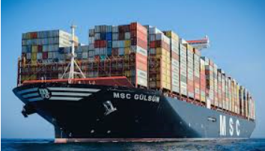  Have you ever wondered how food and other items get to you from other countries a long way away? Most will come by sea on enormous container ships – you may have seen lorries with huge containers on, like this one:  On the sheet attached, name 4 things you think may come to the UK, where we live, on a container ship like this. Draw a picture too.  Now watch the YouTube video of how these containers are loaded and unloaded from the ships onto the lorries.  Using the sheet attached, describe the old and new boats.  Rhyming words – what rhymes with boat (‘oa’ sound) – write some of these as a list in your books. | Make a model of any type of sea transport – you can use recyclable materials like boxes, cartons etc or use Lego or other construction. It would be lovely to see a photo.  https://www.youtube.com/watch?v=Llk0qYLiDBc  Using a sheet of A4 paper, try to make a sailing boat with some help from someone. You could decorate it and name it!  https://www.youtube.com/watch?v=svdvQ9aiGbY  Can you sing this song with Mr Tumble?  https://www.youtube.com/watch?v=xGf1ITv8qM8  A fun ‘I’m on a boat’ song to sing!  Ahoy there me hearties! A good pirate song to sing and join in with the actions!  https://www.youtube.com/watch?v=QVfVIcW1alo  And another one:  https://www.youtube.com/watch?v=ac_vWT6CvLg

If you do not have the weekly book available at home, we have provided a you tube link for your child to listen to the story.
Daily phonics/reading – see separate overview for Mrs.Bacon/Mrs.Sharphouse and Mrs.Witham’s phonics group.
In terms of reading, we have set each child an account up on Epic reading. This will allow them to access reading books online. Head to www.getepic.com/students and follow the instructions below.
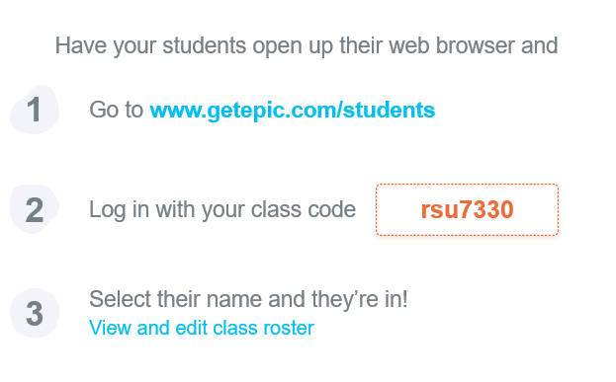

Daily Maths – please continue to use Doodle Maths where we will set challenges for the children. The ‘White Rose Home Learning Programme’ is also fantastic if you wish to have a go. Follow this link https://whiterosemaths.com/homelearning/ and click on the Early Years group on the right hand side of the screen.

