Home Learning – Summer Term 2 Week 6
Under the Sea – Blue Planet
As a guide, we would expect children to do at least three of the literacy activities per week and at least one of the topic activities. We would also expect children to read, practice the sounds of the week (phonics) and complete doodle maths on a daily basis (See the separate suggested timetable for more support if needed)
Weekly focus | Literacy activities (sheets attached) | Weekly topic activity ideas
‘Harry saves the ocean’.  https://www.youtube.com/watch?v=RU7AP4JUX-o  ‘Somebody swallowed Stanley’.  https://www.youtube.com/watch?v=sF1-ZTRydlM&pbjreload=101  Short story about ocean pollution:  https://www.youtube.com/watch?v=i1_37YGzXrc  (the ‘real life’ ones were a little hard-hitting!) | Listen to the stories ‘Harry saves the ocean’ and ‘Somebody swallowed Stanley’. Why is plastic bad if it goes into the sea? Chat with your parents and discuss why it’s not good. In your books, write 2 sentences or more about what can happen to plastic when it gets into the sea.  Watch the short story about ocean pollution – they mentioned Reduce Reuse Recycle – what does this mean?  Think about some of the rubbish people throw away – what can be Reduced, Reused or Recycled? Complete the sheet attached with words and pictures. An example of each has been given.  Find out who David Attenborough is? What does he do and what things is he passionate about?  https://www.youtube.com/watch?v=r-91umZ7cQE | Recycling activity – print off the items to be recycled and the labels and sort the items into the different sections.  Using recyclable materials in your house that are being put into the recycling bin and make a sea creature model. We can’t wait to see what creature you make!  Can you make a cereal box aquarium? It doesn’t have to look exactly like this – you can make shells by cutting pieces of cardboard.  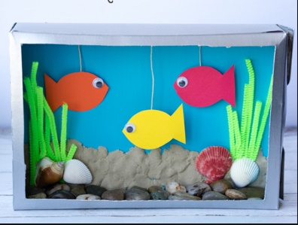  If you can, watch some of David Attenborough’s wildlife documentaries. Here’s a funny clip with a very noisy bird of paradise! https://www.youtube.com/watch?v=2TJaNDBI87s
If you do not have the weekly book available at home, we have provided a you tube link for your child to listen to the story.
Daily phonics/reading – see separate overview for Mrs.Bacon/Mrs.Sharphouse and Mrs.Witham’s phonics group.
In terms of reading, we have set each child an account up on Epic reading. This will allow them to access reading books online. Head to www.getepic.com/students and follow the instructions below.
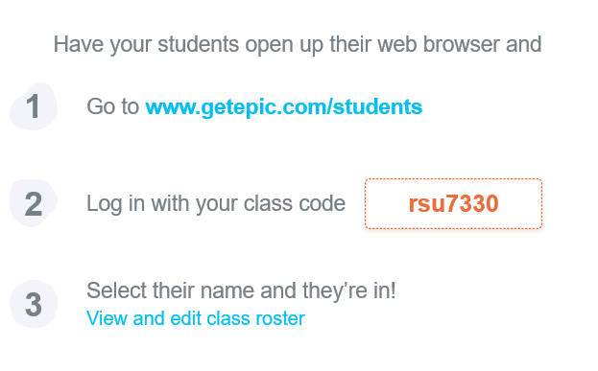

Daily Maths – please continue to use Doodle Maths where we will set challenges for the children. The ‘White Rose Home Learning Programme’ is also fantastic if you wish to have a go. Follow this link https://whiterosemaths.com/homelearning/ and click on the Early Years group on the right hand side of the screen.

