Home Learning – Summer Term
Fantasy and Adventure – Magic and Mythical Creatures
As a guide, we would expect children to do at least three of the literacy activities per week and at least one of the topic activities. We would also expect children to read, practice the sounds of the week (phonics) and complete doodle maths on a daily basis (See the separate suggested timetable for more support if needed)
Weekly book focus | Literacy activities (sheets attached) | Weekly topic activity ideas
‘Room on the broom’ by Julia Donaldson and Axel Scheffler.  https://www.youtube.com/watch?v=cWB0goTWZic  ‘The Singing Mermaid’ by Julia Donaldson and Lydia Monks.  https://www.youtube.com/watch?v=M5W9tjUO5IE  ‘Sugarlump and the unicorn’ by Julia Donaldson and Lydia Monks.  https://www.youtube.com/watch?v=TfmErzwjmXg | - What would you put in your cauldron? Write and draw the items to go in – think of a magic word, wave your magic wand and …… What will happen? What will your spell do?  - Create your own mythical creature – merge two together – what would it be called? Eg a dragon and a mermaid, called a Mergon! Write a sentence about it or challenge yourself by writing a magical adventure.  - Now we are in Summer. Watch the Powerpoint about Summer and the other 3 seasons. What can you wear now the weather is warmer? Can you fill your suitcase for a summer holiday? Don’t forget your sun-cream!  - What changes happen to plants and animals in Summer? Write a list of anything to do with summer. If you want, you could try and use bullet points in a list. | - Make a magic wand – you could use a stick (be careful with it!) Roll up some paper and decorate it.  - Summer! What do you like doing in the summer? Maybe you could start a scrapbook whilst you are at home – stick things in you find eg a feather, a wrapper from a chocolate treat, pictures and photos. A shopping list you have written. Some of your favourite things to do at home.  - Now it’s warmer outside, can you lie in your garden and look at the clouds (don’t look directly at the sun!!). There are lots of different types of clouds – they all hold tiny water droplets. Sometimes the droplets fall on us – what is this called? Can you see little fluffy clouds, big darker clouds?

Daily phonics/reading – see separate overview for Mrs.Bacon/Mrs.Sharphouse and Mrs.Witham’s phonics group (If you are unsure which group your child is in, please don’t hesitate to e-mail us to find out.)
In terms of reading, we have set each child an account up on Epic reading. This will allow them to access reading books online. Head to www.getepic.com/students and follow the instructions below.
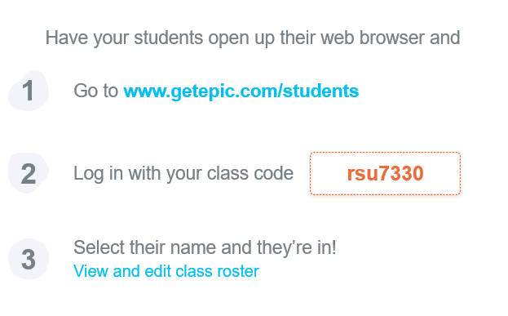

Daily Maths – please continue to use Doodle Maths where we will set challenges for the children. The ‘White Rose Home Learning Programme’ is also fantastic if you wish to have a go. Follow this link https://whiterosemaths.com/homelearning/ and click on the Early Years group on the right hand side of the screen. Scroll to the bottom and click on week 2.

