Home Learning – Summer Term
Fantasy and Adventure – Space
As a guide, we would expect children to do at least three of the literacy activities per week and at least one of the topic activities. We would also expect children to read, practice the sounds of the week (phonics) and complete doodle maths on a daily basis.
Weekly book focus | Literacy activities (sheets attached) | Weekly topic activity ideas
‘Aliens love underpants’ by Claire Freedman and Ben Cort.  https://www.youtube.com/watch?v=HWbSrmuyptw  Our solar system:  https://www.youtube.com/watch?v=Qd6nLM2QlWw  This is quite detailed but is explained very well. A lot of the children will find this very interesting. | - Design your own alien. Write a sentence (or two) about your alien. How many eyes does it have? Does it have any antennae? Does it have teeth?  - Label the space rocket. Additional activity – Choose one or two labels and write it into a sentence.  - If you zoomed off into space, what would you take with you? What could you not leave behind? Would you take your favourite teddy? Would you take a torch? Write in sentences and draw a picture.  - Can you look at the powerpoint about astronauts and then write some facts? What do they wear in space? How do they sleep? | Do you have playdough or plasticine? Can you make some aliens or a spaceship? Take a photo for us please and send via Class Dojo.  https://www.youtube.com/watch?v=OnoNITE-CLc  Wow! Imagine going into space on a space rocket! Design your own rocket.  What is life like up in space on the International Space Station? Have a look at this clip on YouTube. It’s 30 minutes long so you don’t need to watch it all:  https://www.youtube.com/watch?v=06-Xm3_Ze1o  Can you move around as if there is no gravity? What do you think it would be like? Make a den and pretend you are on a space mission to Mars! (Send us any photos on Class Dojo!)  Additional activity – Can you make a split pin astronaut? (you can use glue instead of split pins!)  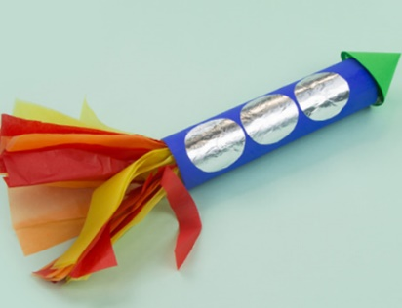  Space craft – Can you make a carboard tube rocket?

If you do not have the weekly book available at home, we have provided a you tube link for your child to listen to the story.
Daily phonics – see separate overview for Mrs.Bacon/Mrs.Sharphouse and Mrs.Withams phonics group (If you are unsure which group your child is in, please don’t hesitate to message us on Class Dojo)
Daily Maths – please continue to use Doodle Maths where we will set challenges for the children.

